|  |  |
| --- | --- |
| Assignment - 1  Advanced Programming  Submitted to: Dr. Sidra Sultana | |
| Name/Reg. no: Aamna Sarosh/218953 | **Section: CS-7A** |

**WordPress**

The OSS I used is a software used for creating websites, blogs and publish it on the internet. It is basically a content management system (CMS) and one of the most popular website publishing programs. It can be used to create blog, e-commerce, business, news etc. websites. It is highly customizable and easy to use software. You can use hundreds of thousands of WordPress’ themes, widgets and plugins to increase its functionality.

**Frontend View**

Here’s the homepage of my wp site named ‘**assignment1’**. At this point no customization is done, it’s the default look.

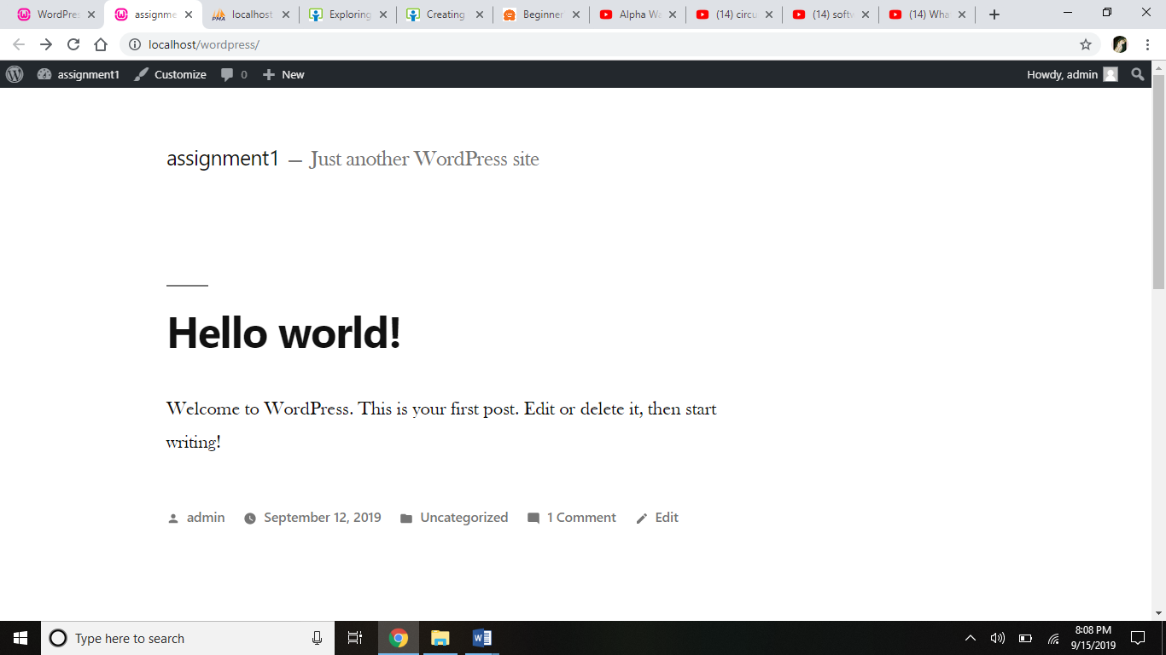

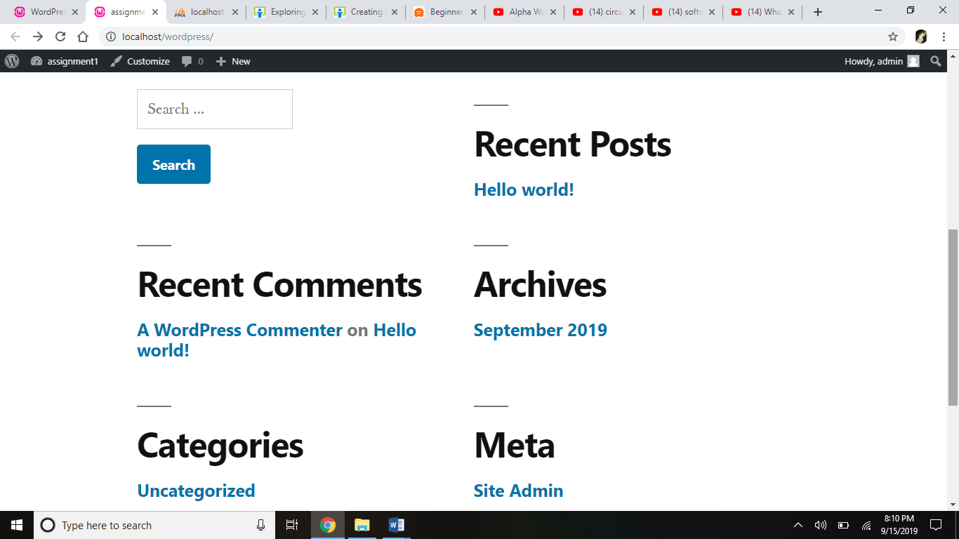

I will make some customization in this site which will be further briefly discussed below.

We can also customize this website on the frontend using the ‘customize’ option. But for this assignment, I’ll be making changings through wp dashboard.

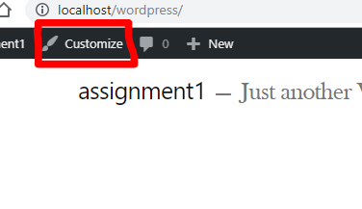

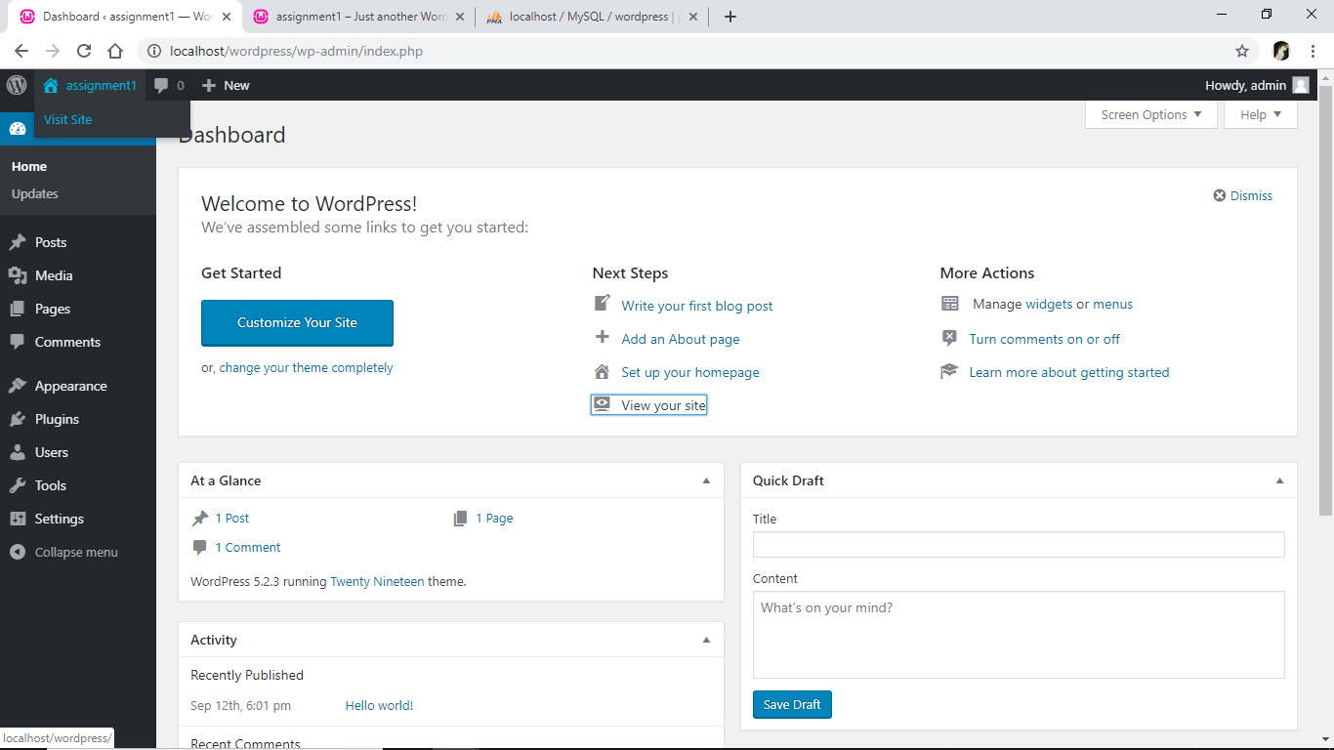

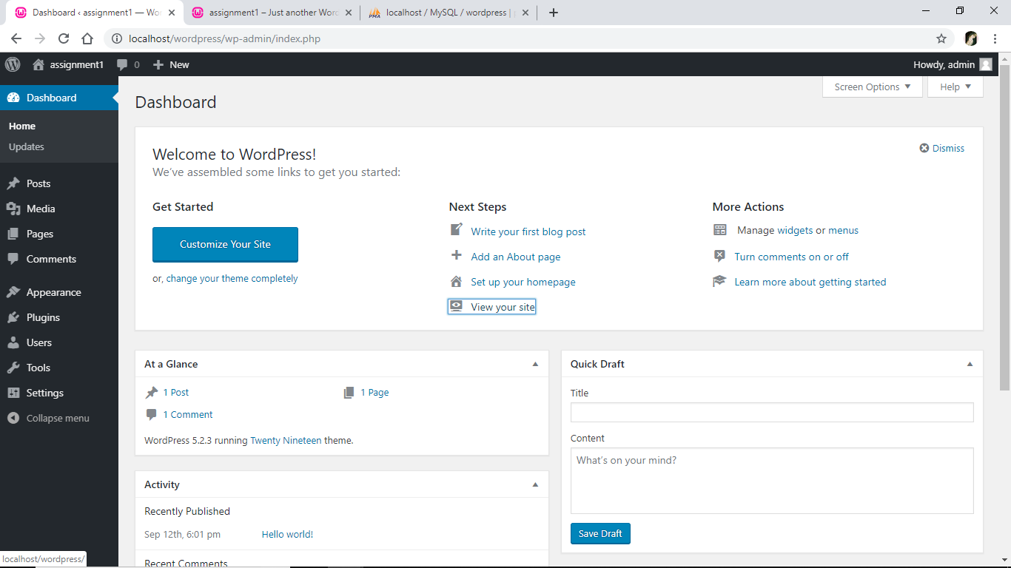

**File and Directory Structure**

Following is the screenshot of files and folders found in WordPress directory.

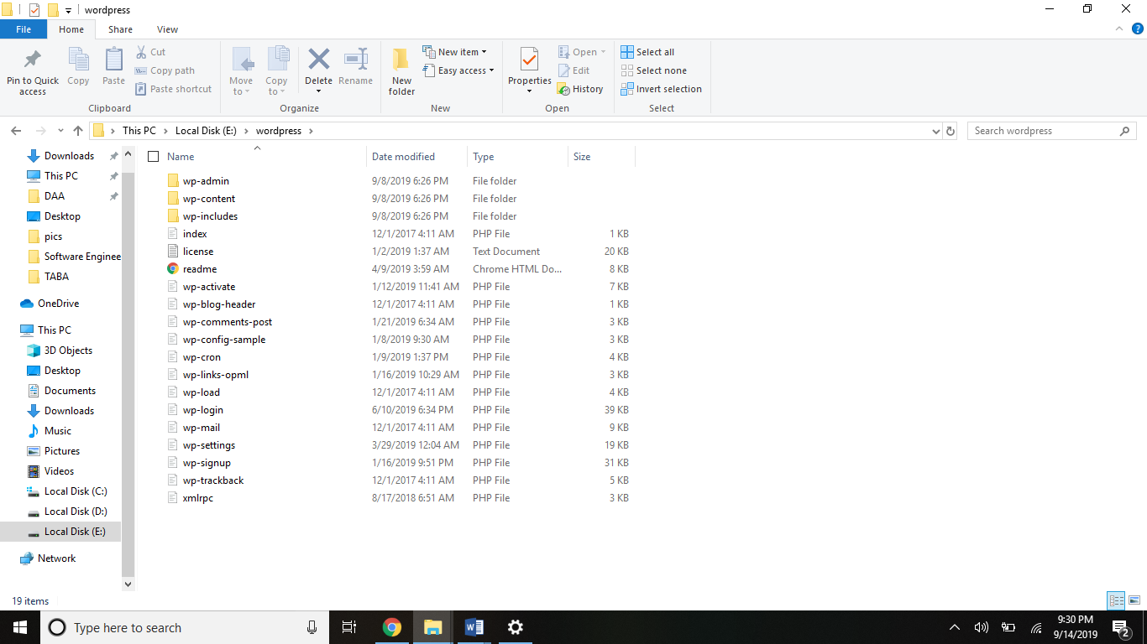

Wp folder contains three top level folders that are content, admin and includes. Let’s discuss them one by one.

**Wp-content folder**

The content folder stores **plugins**, **themes** and **uploads** of wp.

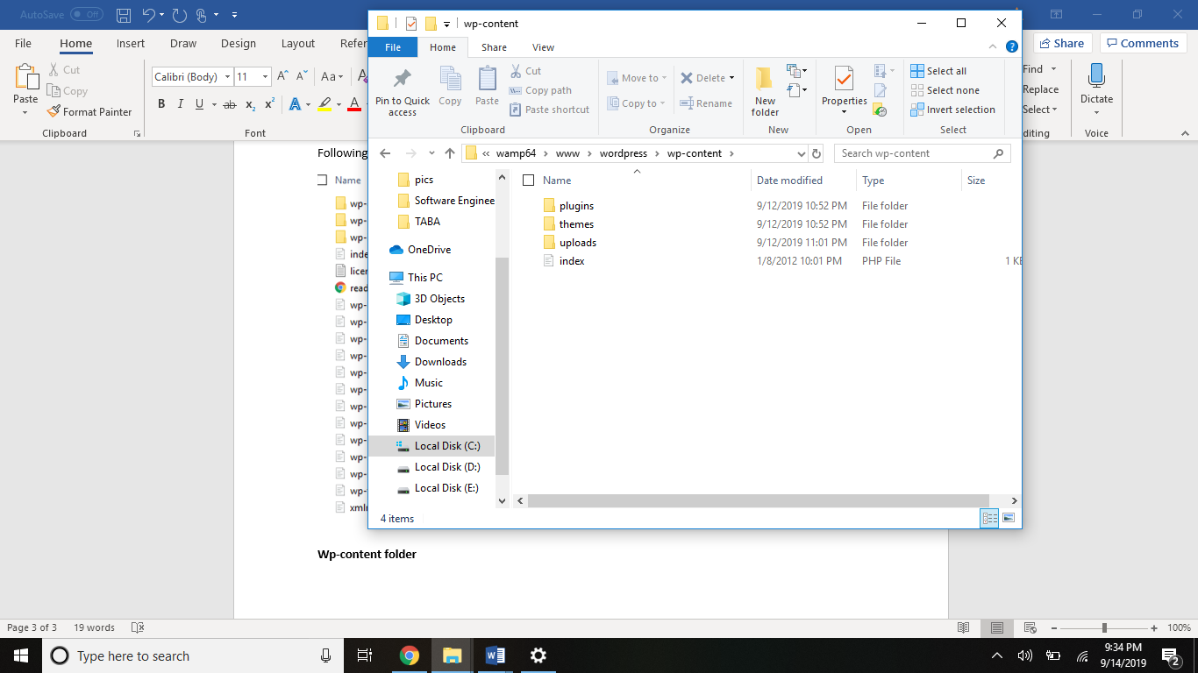

/Wp-content/**themes** folder stores all the themes installed in your WordPress.

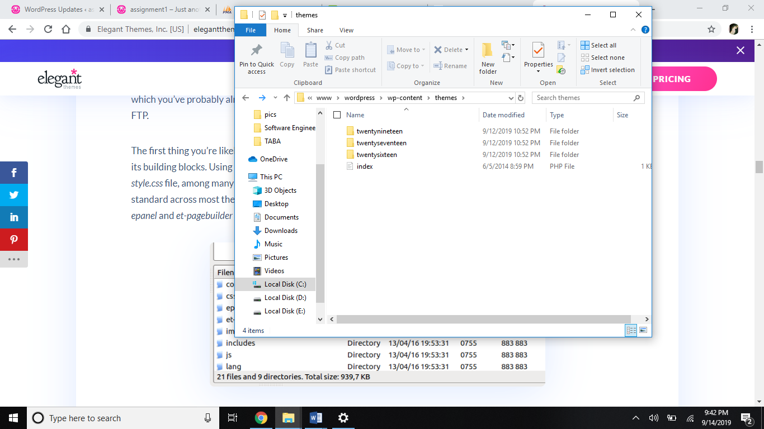

Each theme folder has its own **css**, **js**, **images**, **font**, **styles** files/folders.

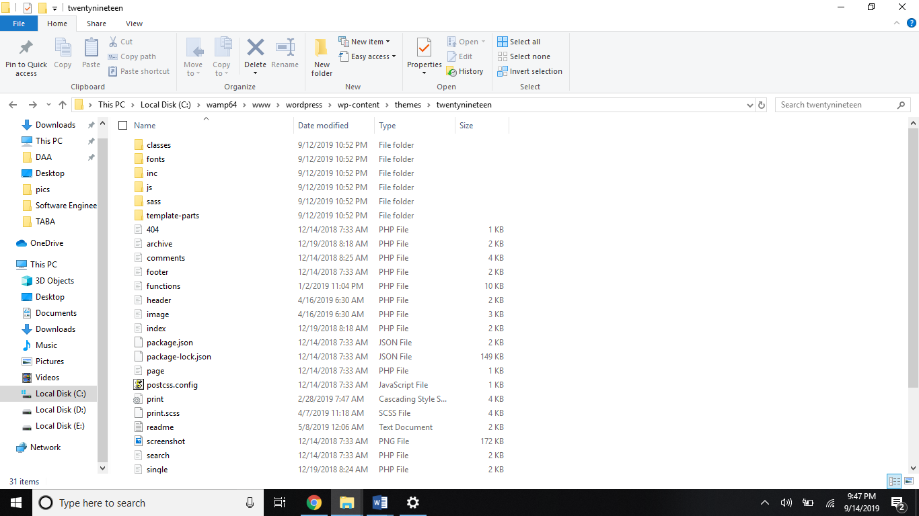

The **plugins** folder has all plugins installed in your wp. Each plugin has its own files and sub-folders.

The **uploads** folder stores all image and media uploads of your wp sorted in the form of separate directories for year, month and dates.

**Wp-admin**

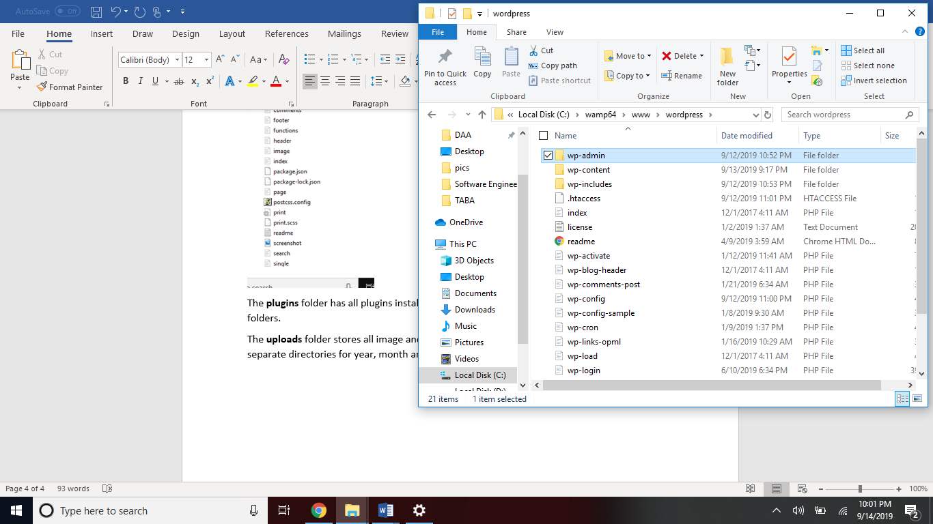

Wp-admin contain all the files and folders about admin control panel.

These files are for the dashboard. E.g. theme-install.php is for theme-installation, profile.php for user administration screen, plugin-install for installation of plugin in dashboard’s plugin panel.

**Wp-includes**

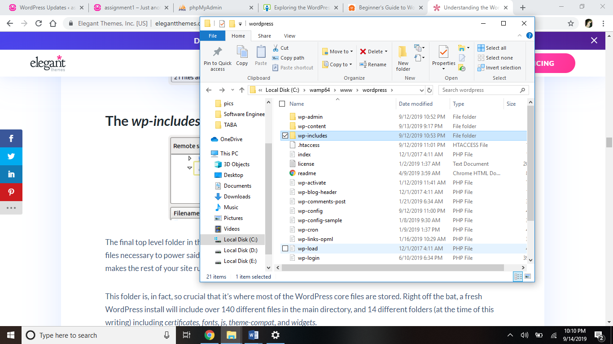

This folder contains common files and directories needed to run wp via frontend. This folder includes the packages included by core and you should never modify these files, these files read only.

The **wp-activate.php**, **wp-signup.php** and **wp-login.php** files is responsible for confirmation and login processes.

The **wp-config.php** has database info.

The **index.php** is for front page and loads wp-blog-header.php which loads the theme.

The **readme.html** file contains all the basic info summed up in one file like installation procedure, license, version, requirements, links and final notes.

**Database Structure**

By default, wp database has **12 tables** as shown in following screenshot. When you install plugins and other modules, new tables are created that have data for those plugins.

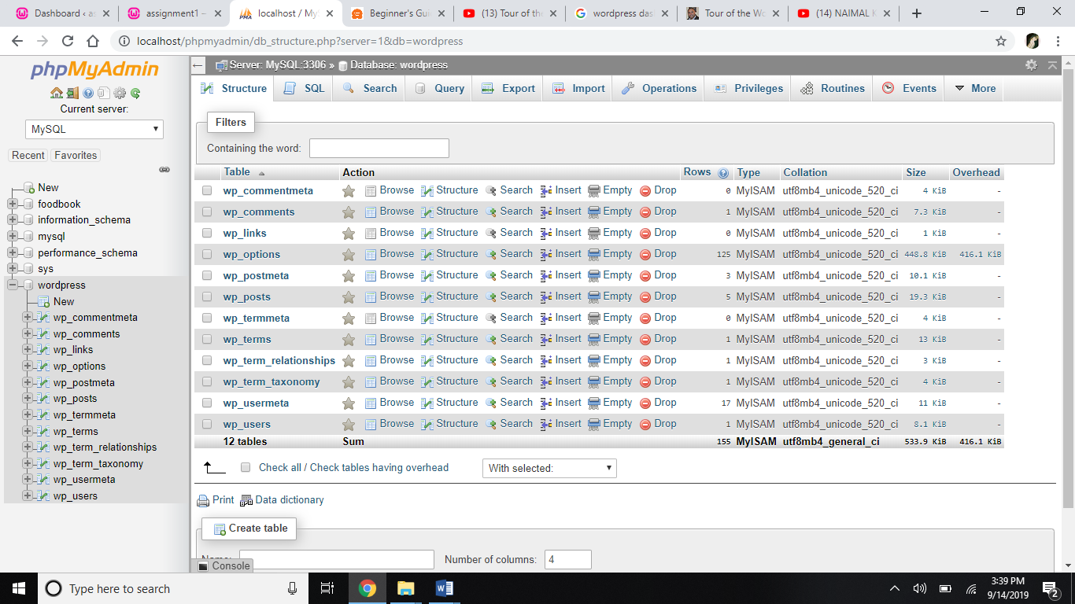

**Wp_users**

This table contains the basic user information like username, id, password, email etc.

Following screenshot shows the 10 fields of wp_user table.

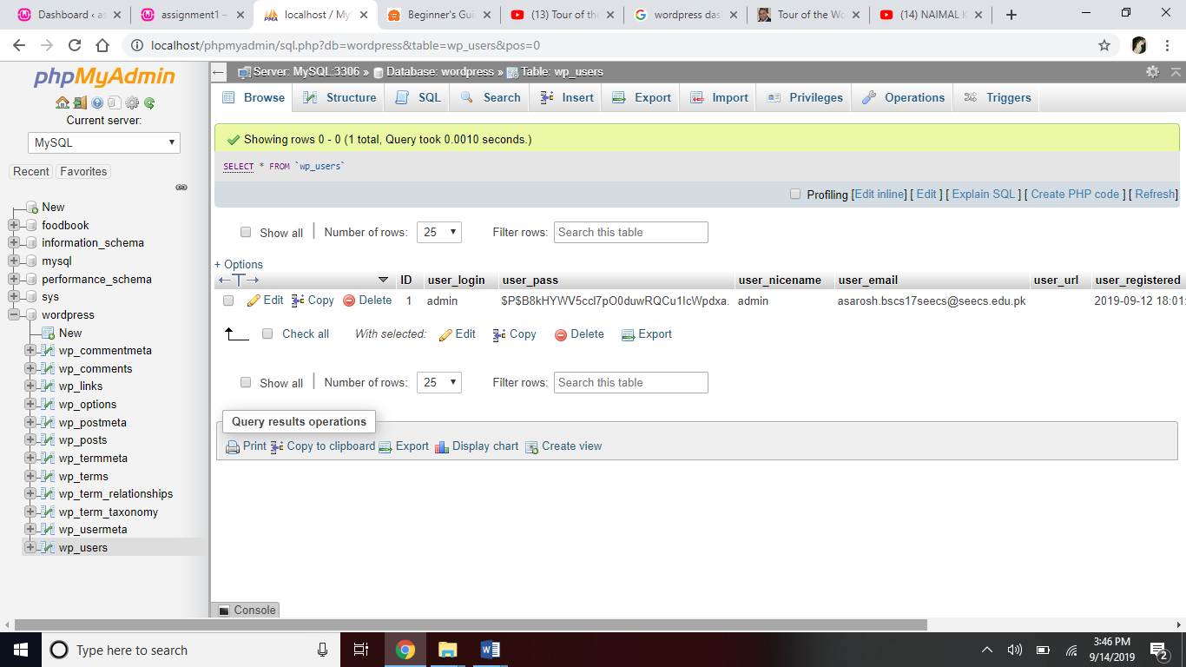

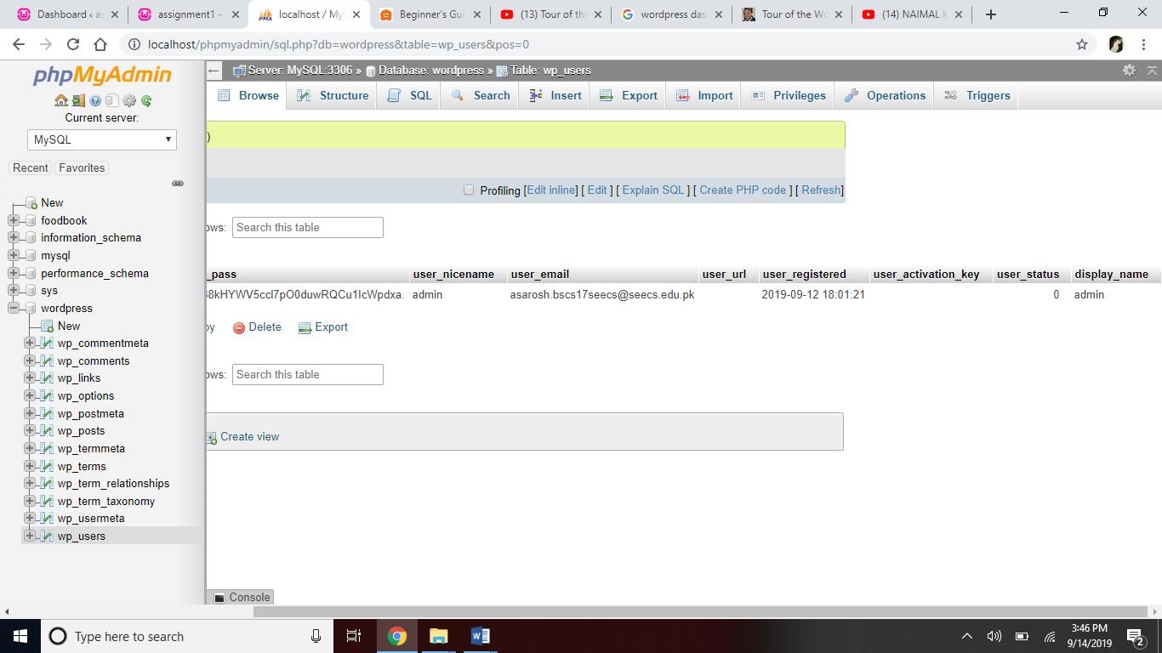

**Wp_usermeta**

Another table that stores user’s info is wp_usermeta. It contains additional info.

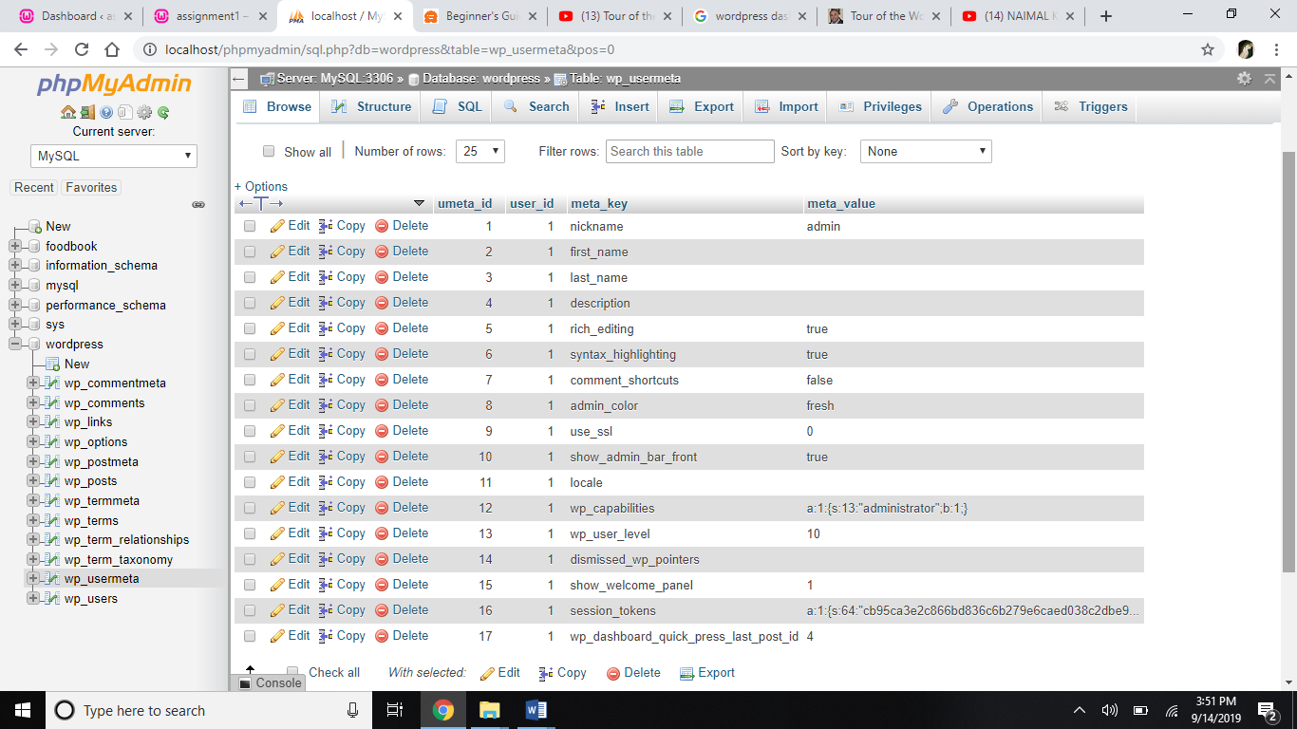

**Wp_options**

This table stores the website settings like url, name, theme, active plugins etc.

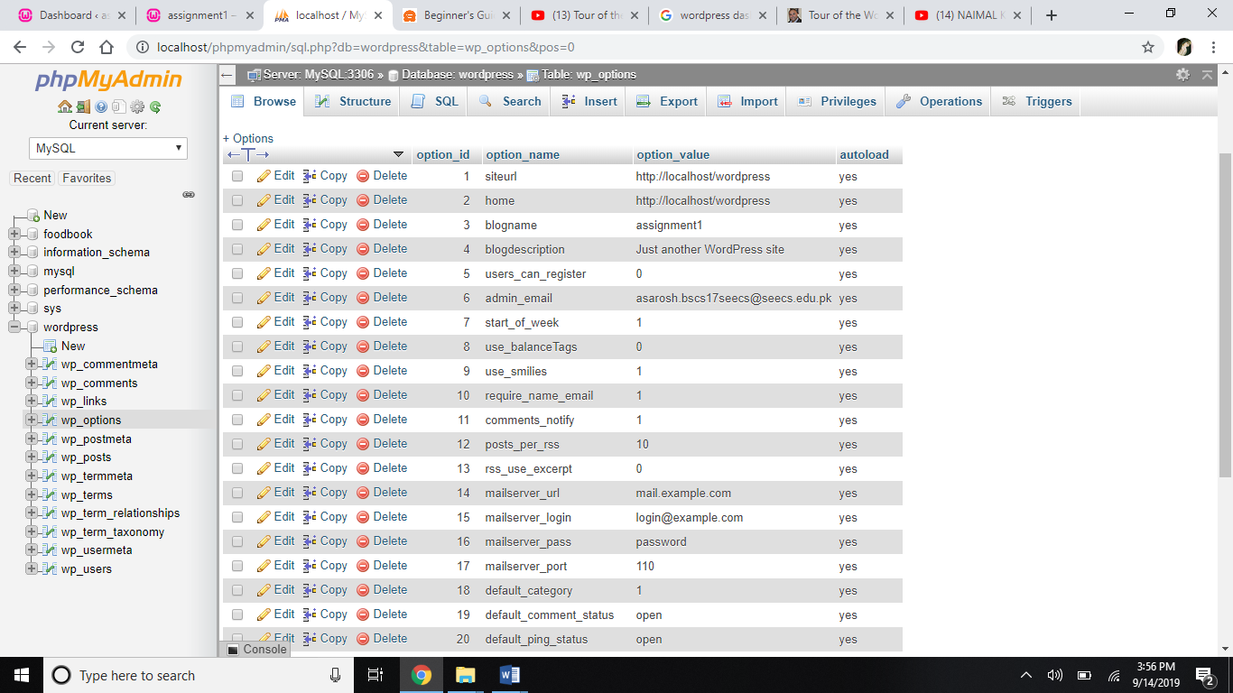

**Wp_posts**

This table stores the website content like pages, posts, attachments and menu items and information regarding these contents.

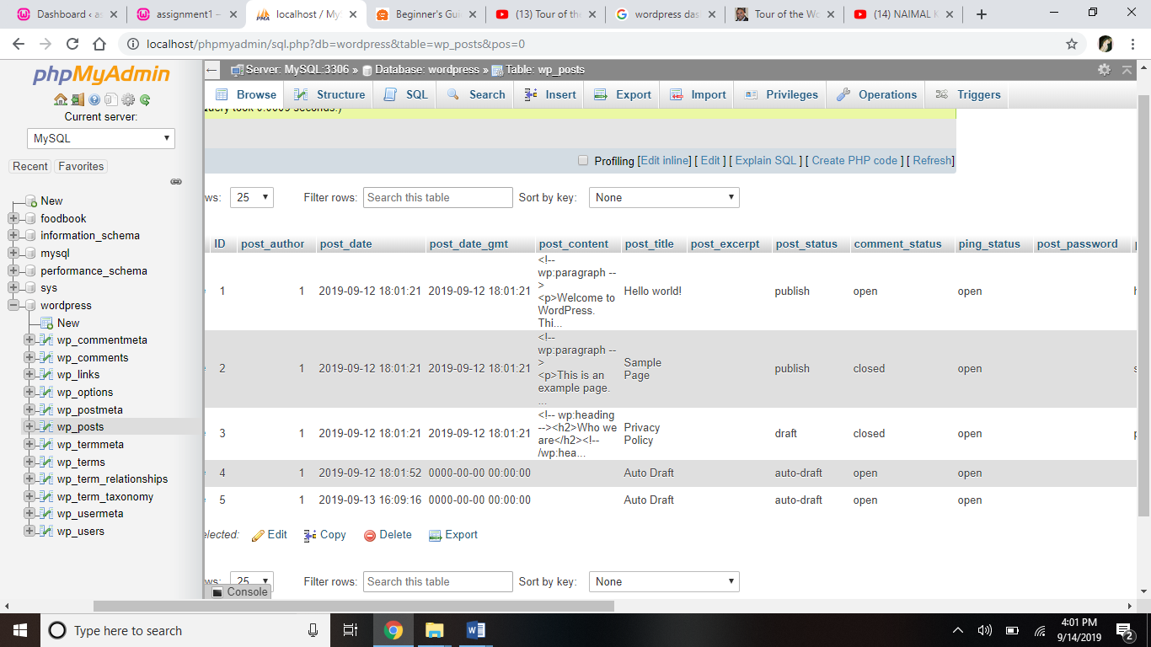

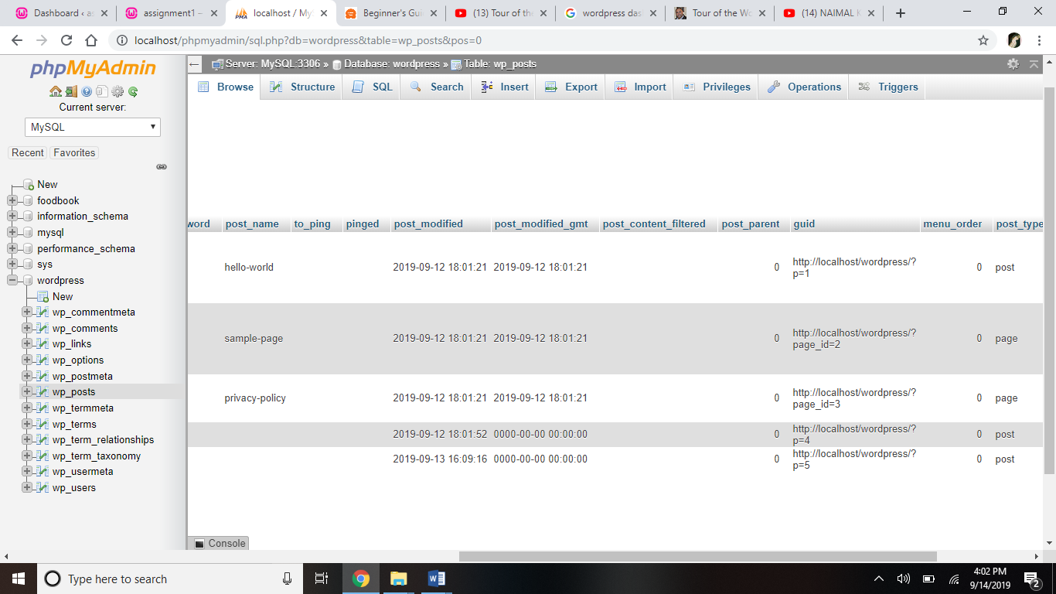

**Wp_postmeta**

This table stores additional info regarding individual posts.

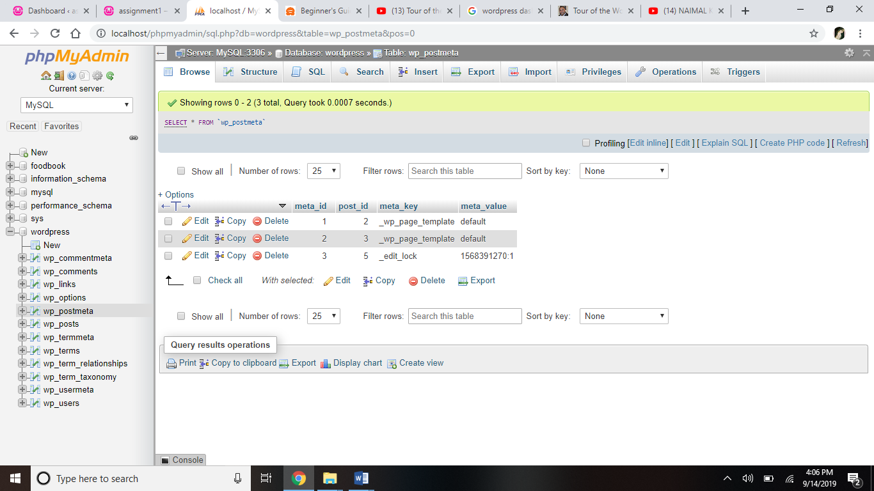

**Wp_comments**

The comments table is where all the comments and their data is stored.

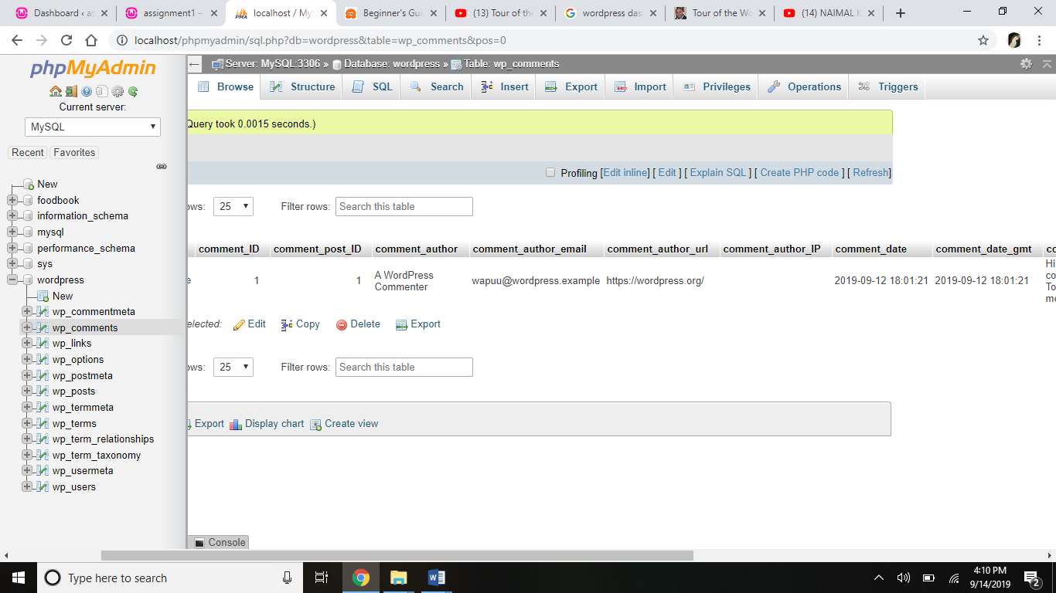

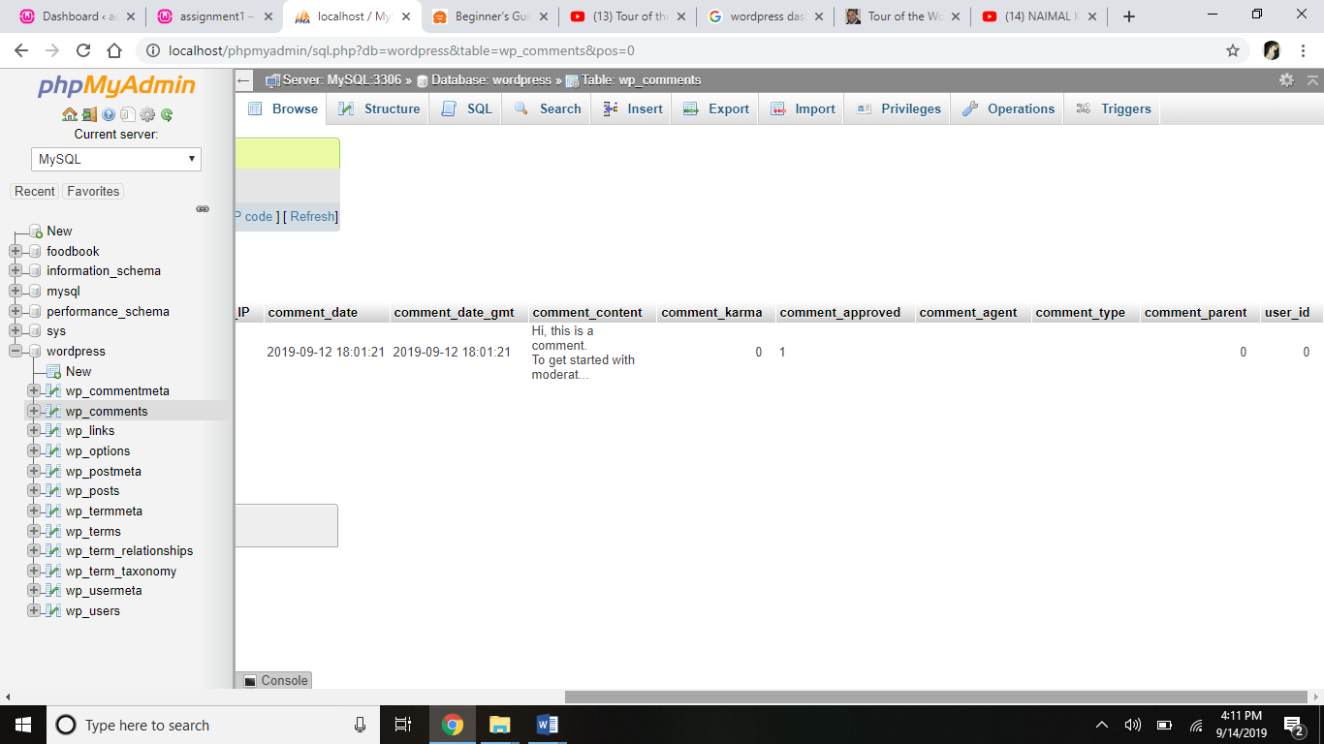

**Wp_commentmeta**

This table stores additional info about comments.

The **wp_terms**, **wp_term_taxanomy**, **wp_term_relationships**, **wp_termmeta** store information about classification or categorization of content/posts.

**WordPress Dashboard**

Here’s a screenshot of wp dashboard home screen after first login.

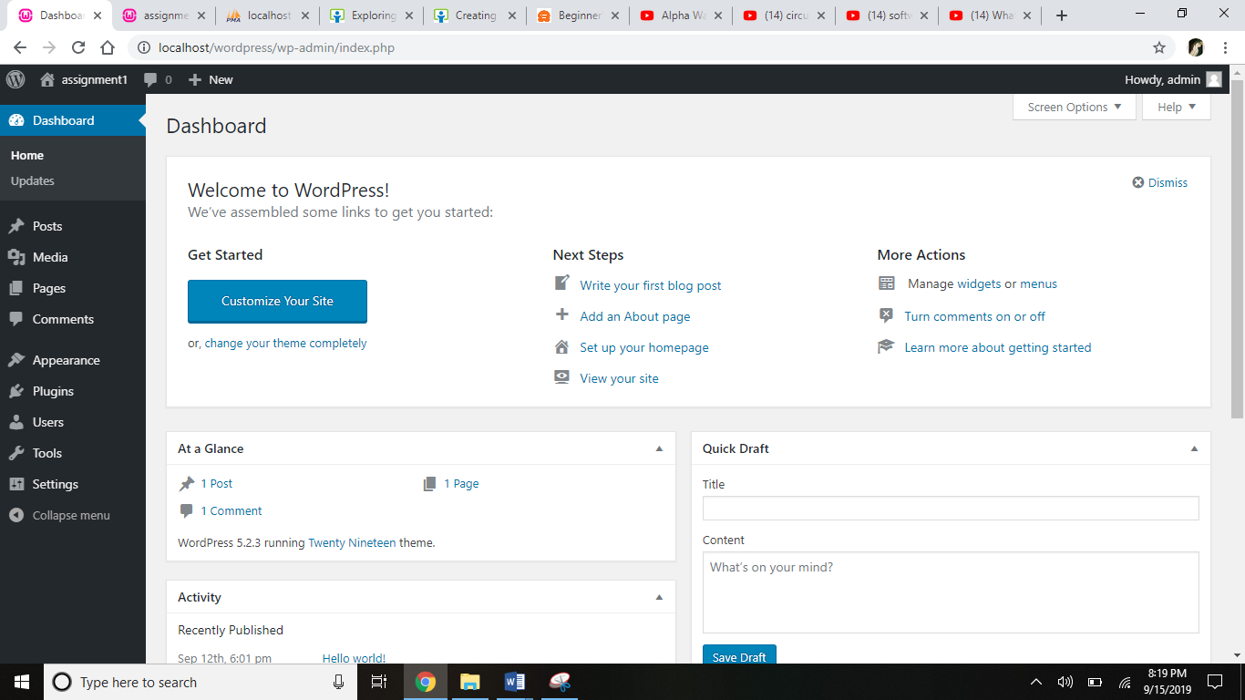

**At a Glance**

This section shows the number of pages, posts, comments, tags, categories and current theme of my website.

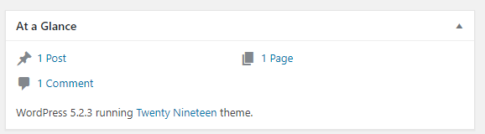

**Quick Draft section**

As the name suggests, this section allows to publish or save draft of post with formatting.

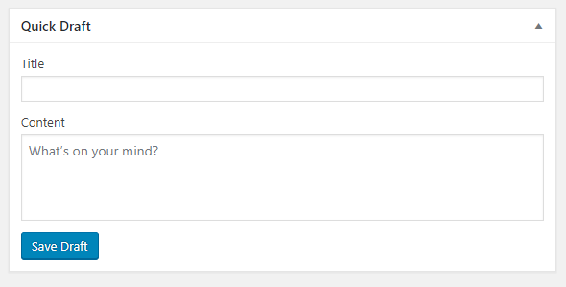

**Menu**

This is the left-hand navigation menu.

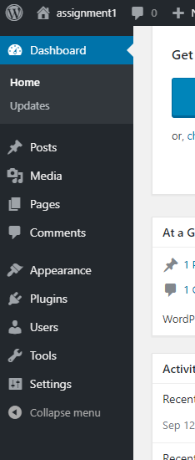

**Customizations in Dashboard**

**Posts Panel**

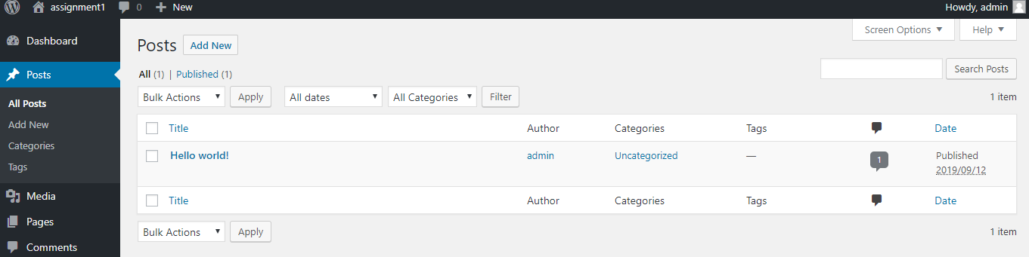

Adding a new post and customization

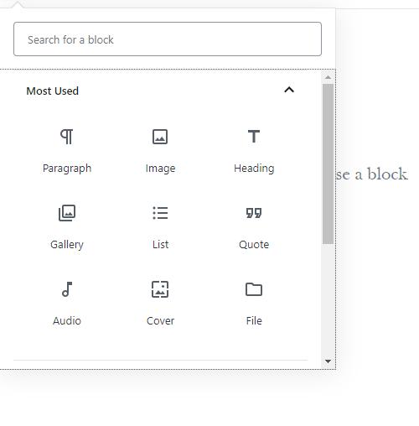

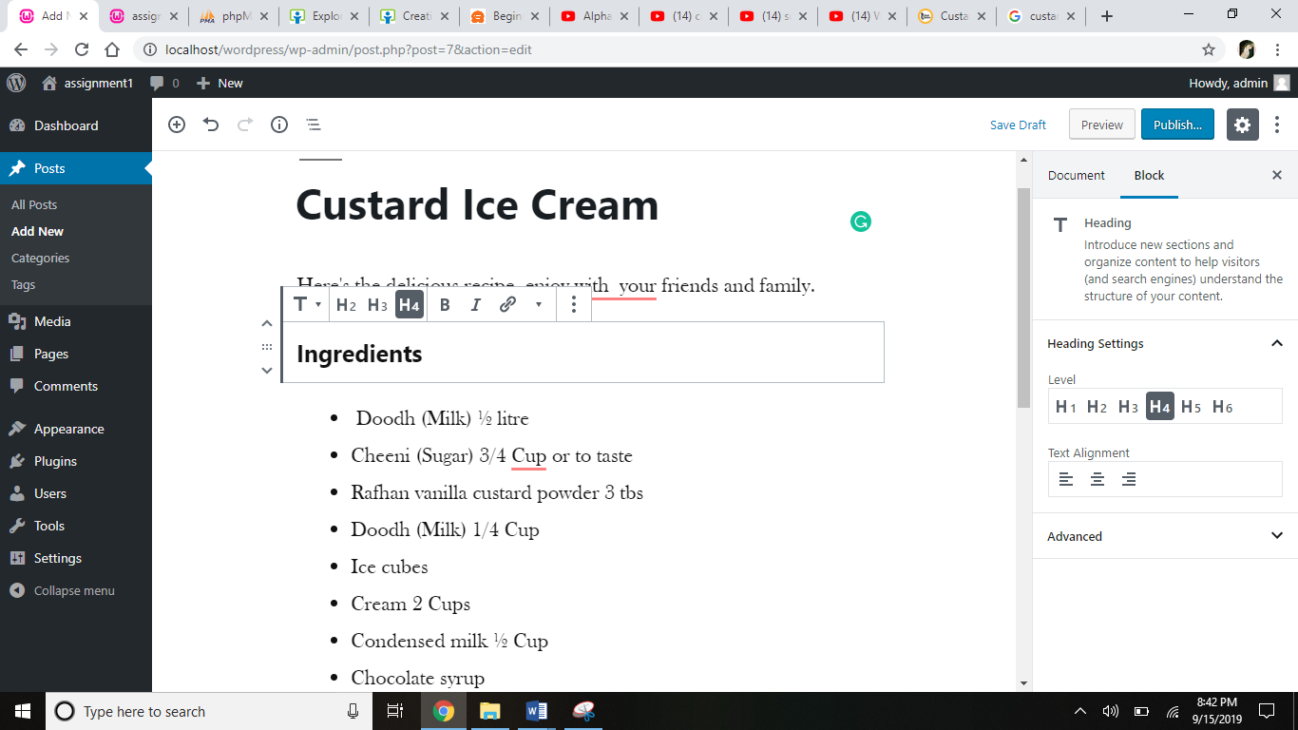

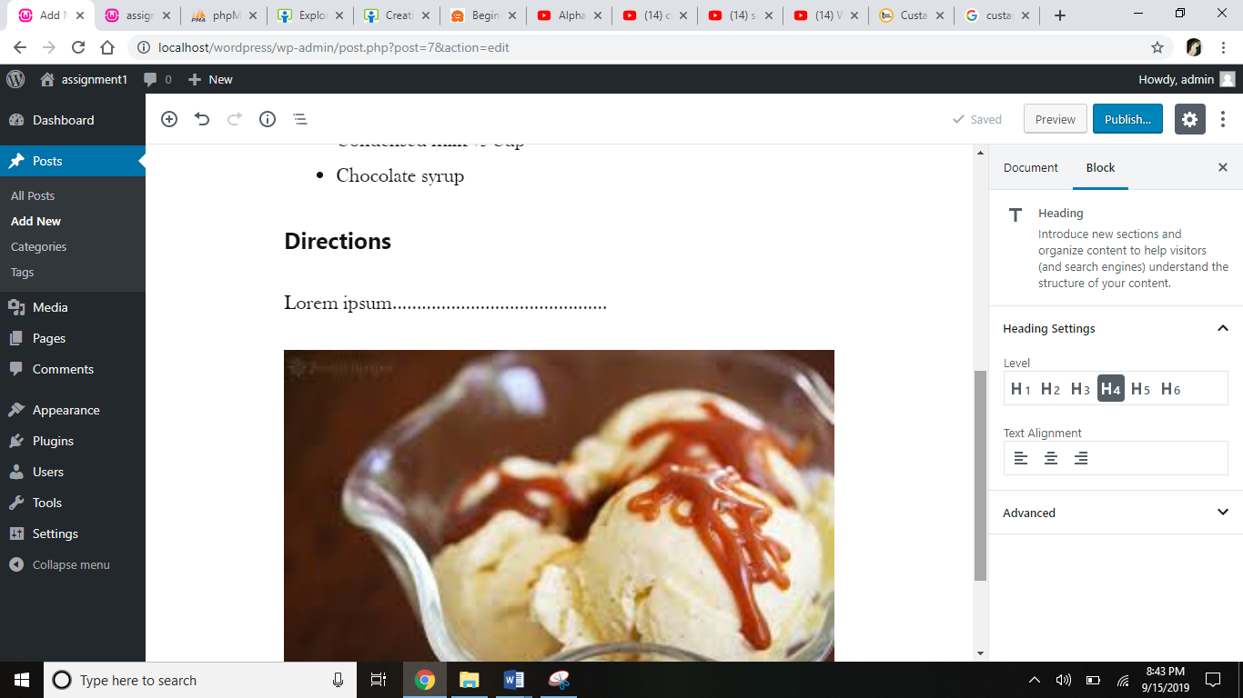

Publishing and adding tag

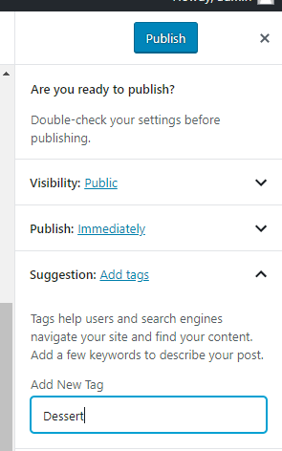

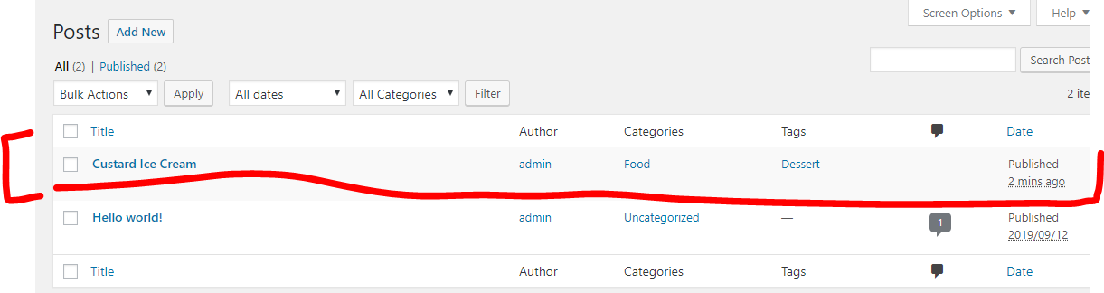

**Media Panel**

Media content of website is in Media Library

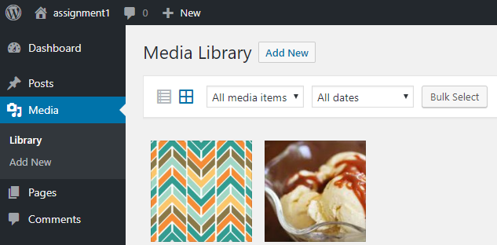

Uploading new files

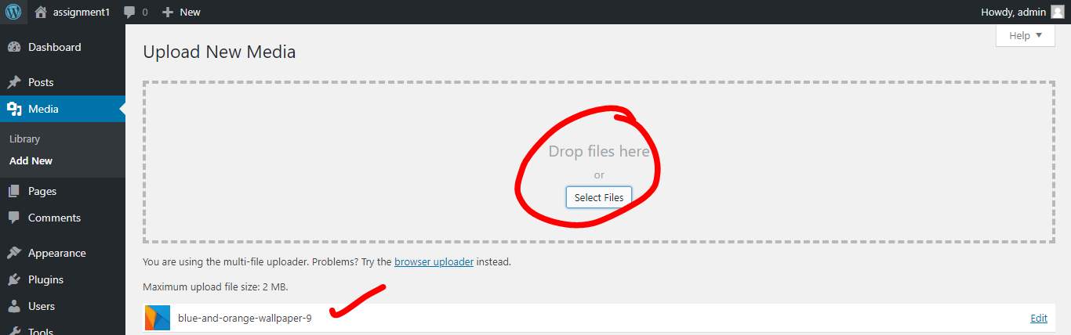

**Pages Panel**

Adding a new page

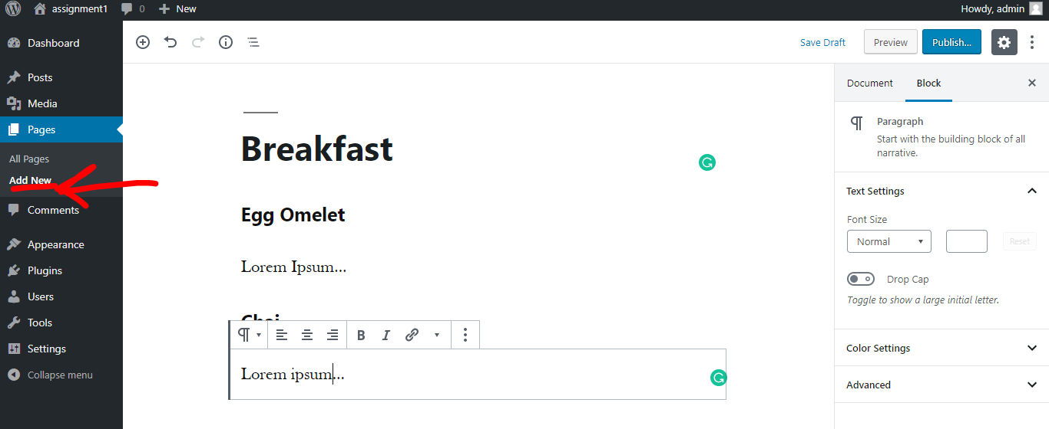

New page added in library

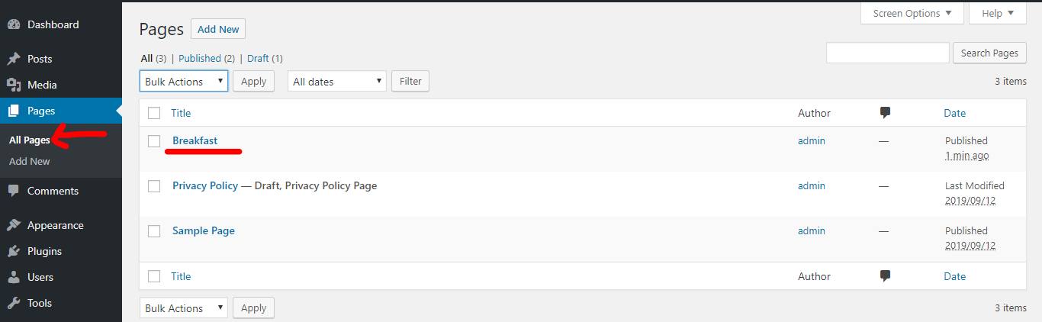

**Comments Panel**

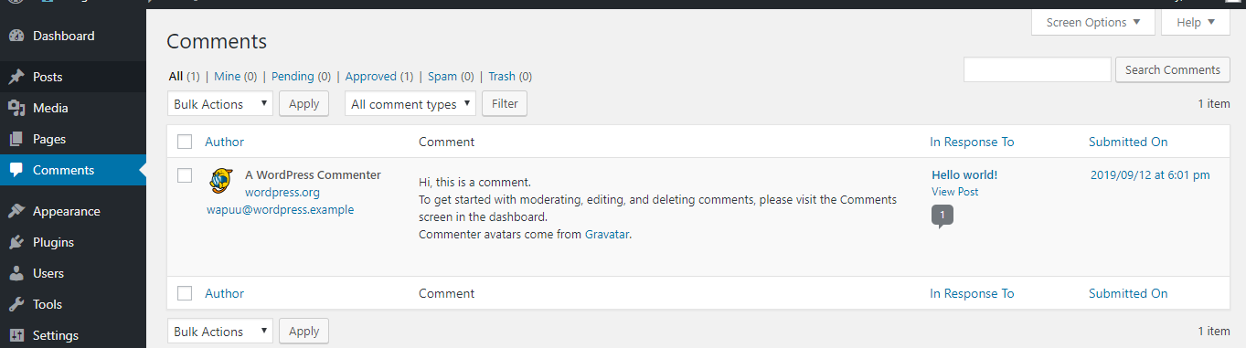

**Appearance Panel**

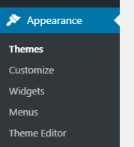

The appearance panel is for customization of themes, menus and widgets.

**Themes**

By default, my wp has three themes. We can add more.

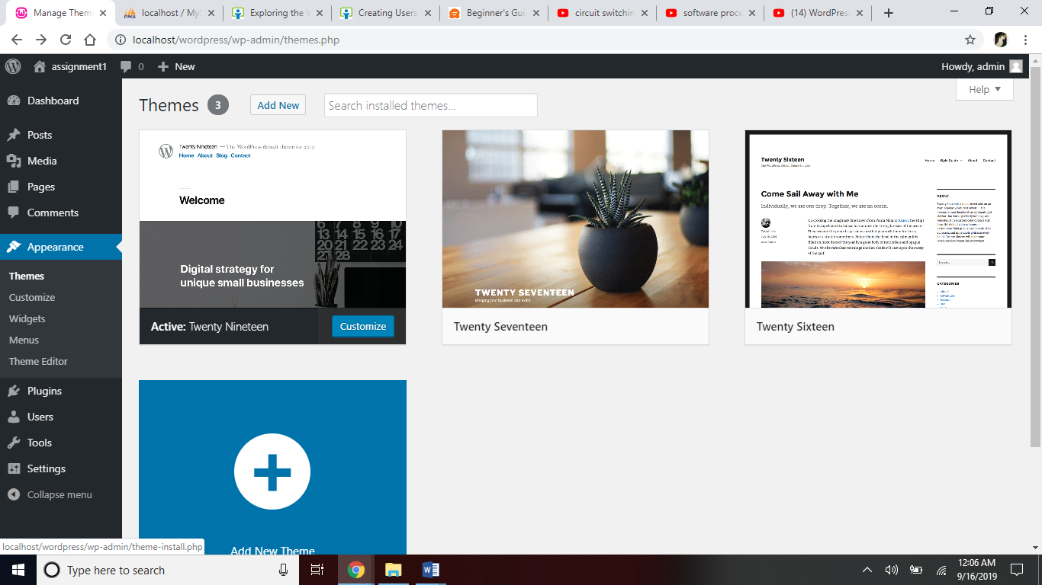

The gray color means that specific theme is activated, applied to my website.

Applying the Twenty Seventeen theme to my website.

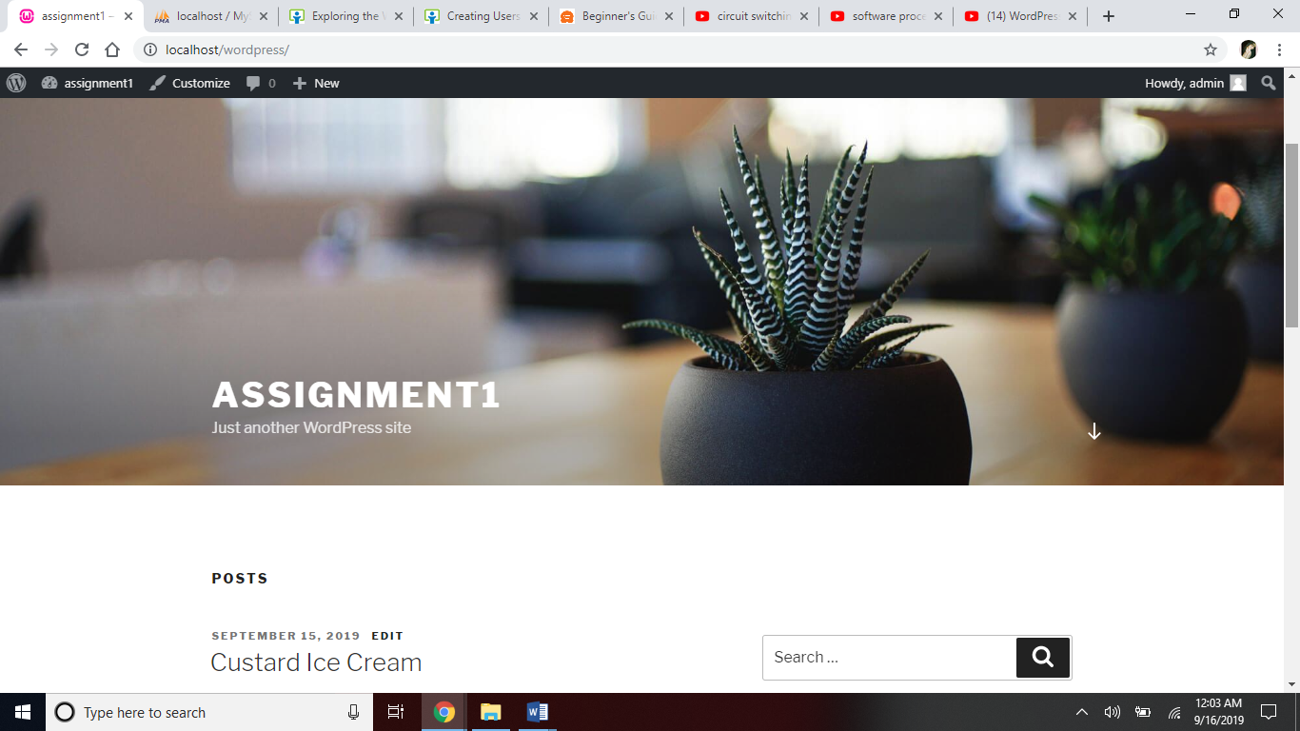

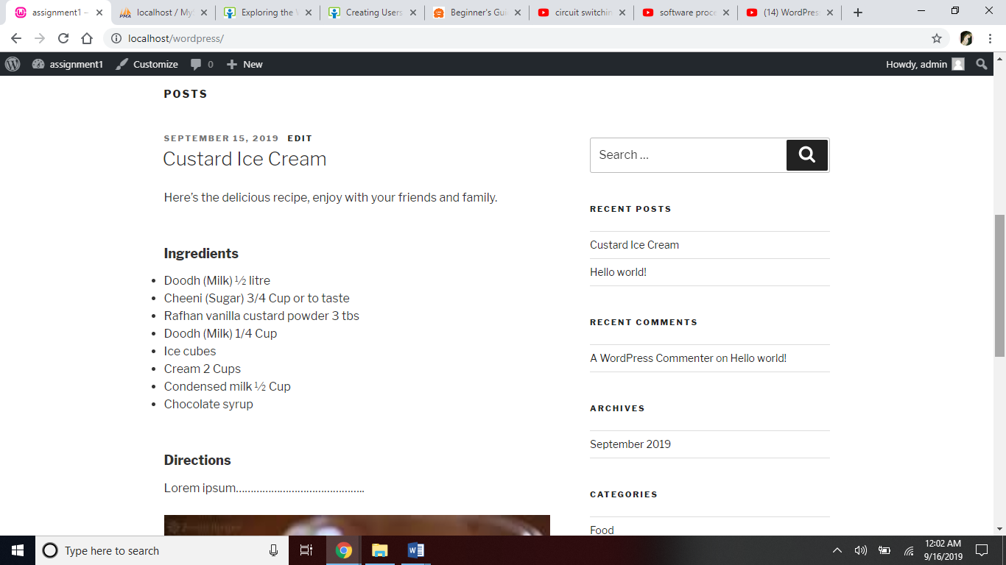

Adding new themes

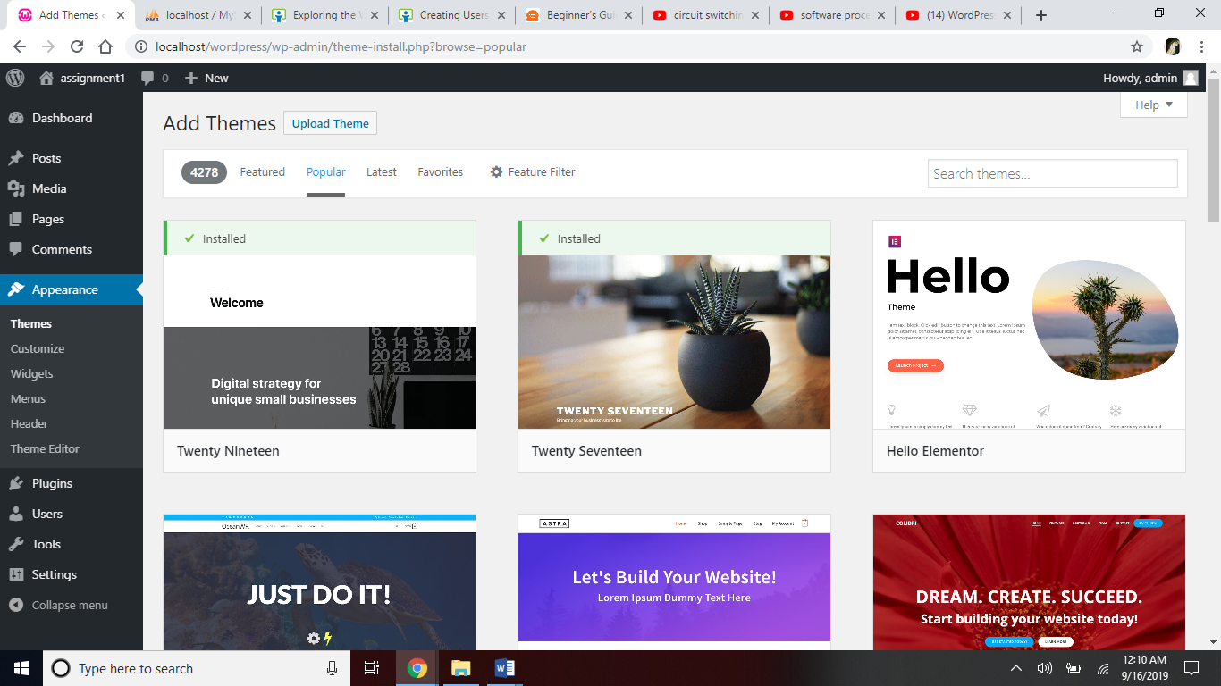

Installing new theme ‘Uptown Style’ and applying it to my website.

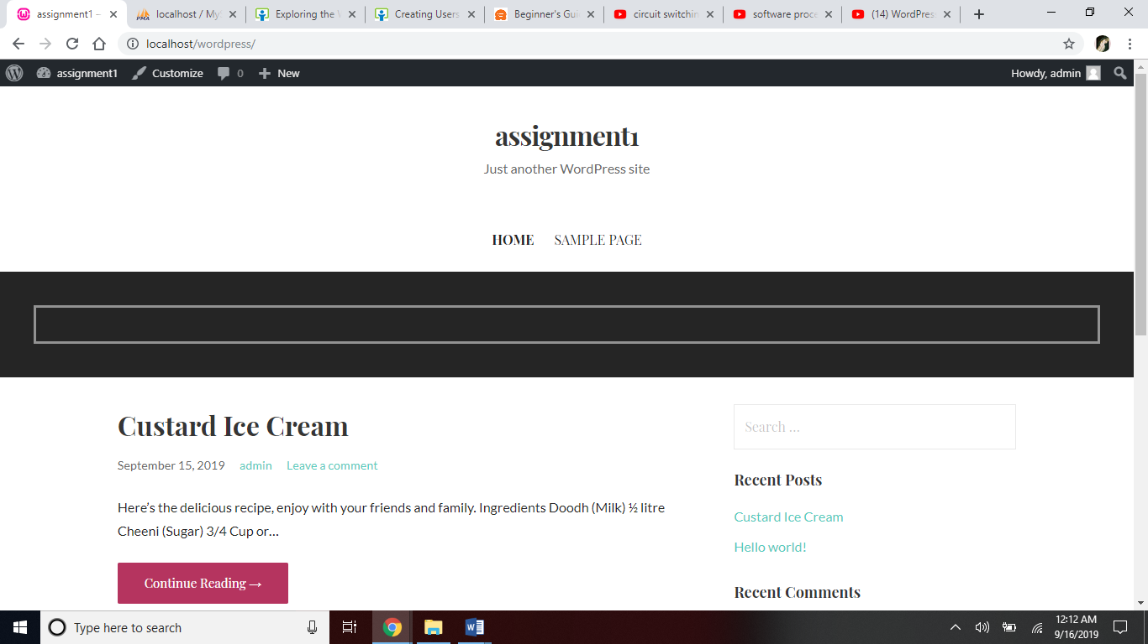

**Widgets**

Adding calendar widget to my website

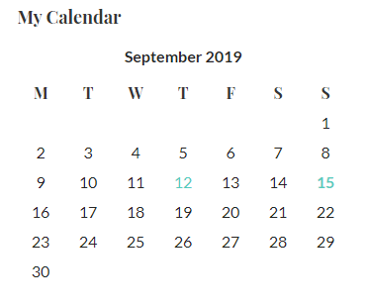

**Header**

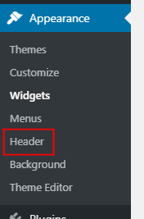

Modifying my website’s name and tagline using header section.

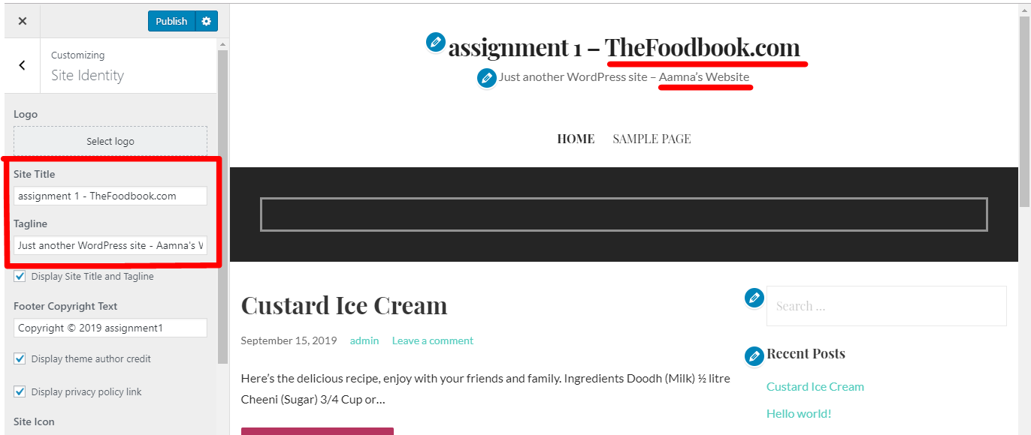

**Plugins panel**

Installing new plugins

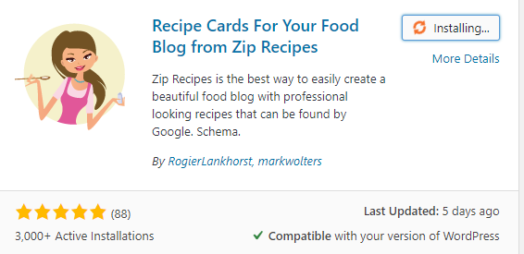

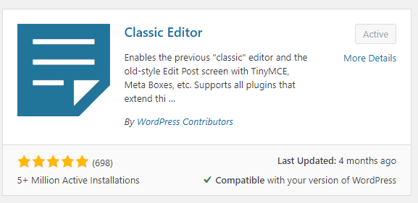

Activating new plugin



Using this new plugin

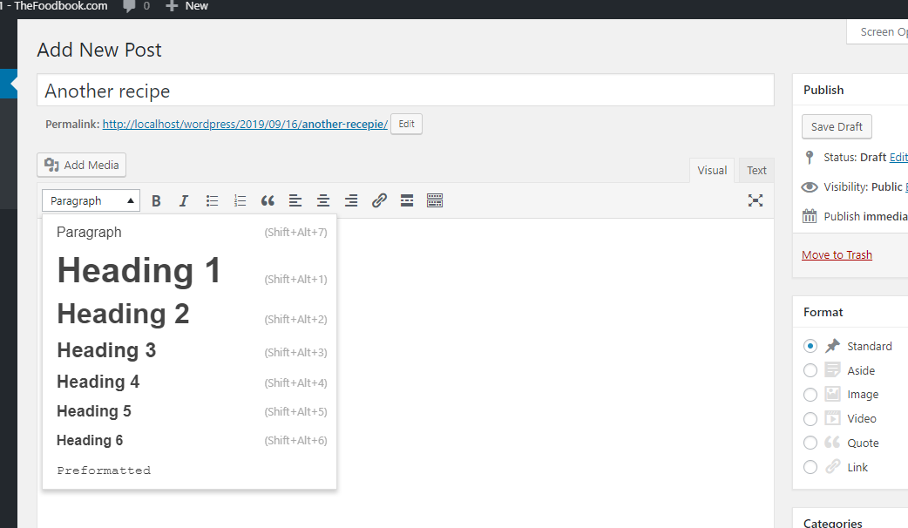

**Users Panel**

Wp has 5 kind of users. Administrator, Subscriber, Contributor, Editor and Author.

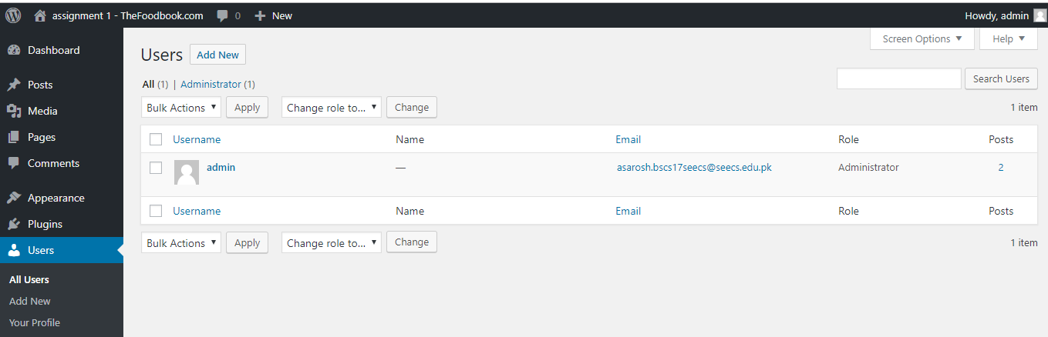

Adding new user as an editor



**Settings panel**

